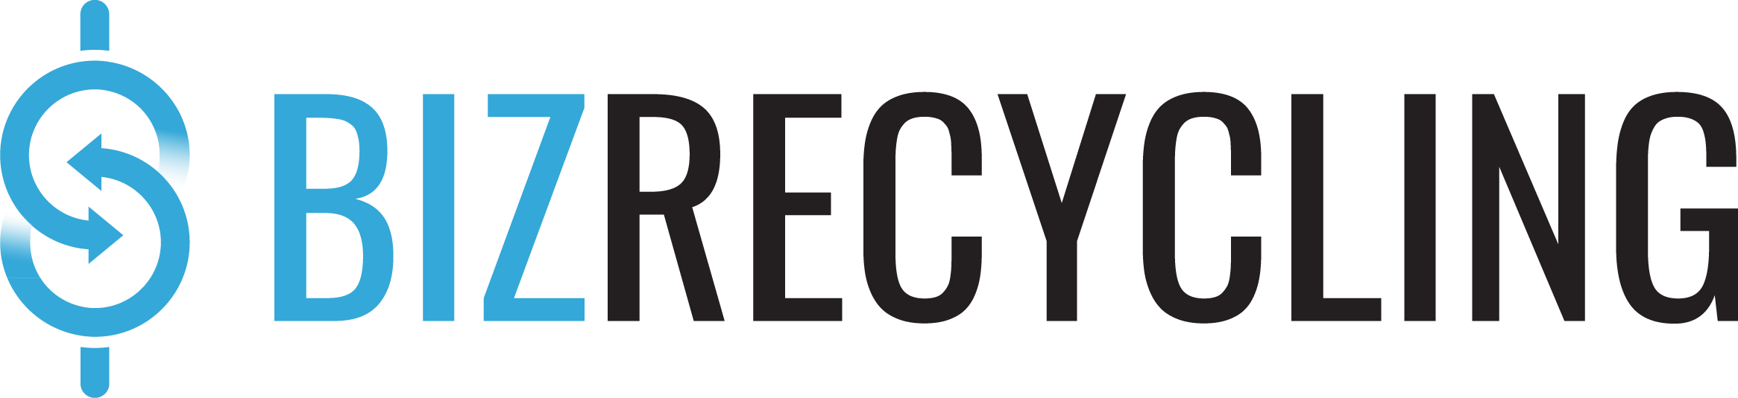
BizRecycling Partners
Status Report: 6 Months

A status report is due in month 6 of your contract year. Upon approval of the report, you will receive payment of the remaining portion of your grant for the year. Email your completed report to info@bizrecycling.com.
Today’s date: ____________________

Contact Information
Business Name
Contact Name
Contact Title
Mailing Address
Phone Number
Email Address

Project Status Update
Provide a status update for each outreach objective as stated in your Annual Work Plan. If there were changes to the project scope or budget, include information explaining the changes.
From Annual Work Plan | 6 Month Status Update  (Include activities, outcomes, or proposed scope changes.)
Objective 1

Objective 2

Objective 3

Objective 4

Budget Status
Provide an update on the budget expended to date. Include any budget modifications that have occurred.

Line Item | Description | Amt Applied For | Amount spent as of 6-mo
Staff/Personnel (Number of hours by staff)
Printing and Postage
Advertising
Outreach Activity Expenses (i.e. supplies, room reservation fees)
Other Expense:
Other Expense:
Grant Total

Additional Comments
Is there additional information you would like to share? For example, successes you’ve had in recruiting business, challenges your businesses are facing, or additional supports needed from the BizRecycling staff.

